RHP 6 Community Needs Assessment
RHP 6 represents about nine percent of the state of Texas in terms of population and geography. Like Texas, RHP 6 has a high uninsured rate and reported health outcomes are often poor. Key health challenges include limited access to primary care, unmet mental and behavioral needs, chronic disease, and provider shortages. The need for improved healthcare infrastructure will continue to increase as the population is expected to grow and more Texans gain coverage under the Affordable Care Act.

Demographics
Population
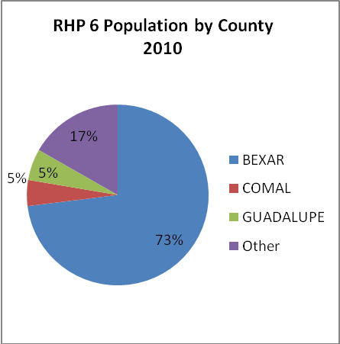
The 20 counties in RHP 6 cover 24,734 square miles, comprising approximately 9.5% of the total land area of Texas. In 2010, there were 2.3 million people living in this region, accounting for 9% of the state’s population. Seventy three percent (73%) of the RHP population resides in Bexar County. The majority of RHP 6 residents are Hispanic (54%) and Anglo (37%). This differs from the state as whole, which is 46% Anglo and 38% Hispanic.
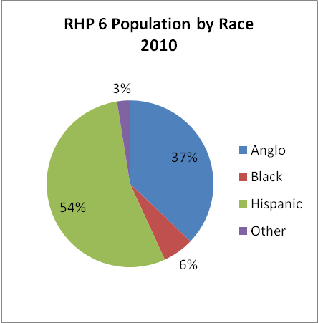

In terms of age, 26% of the RHP 6 population includes children under the age of 18 years, while 12% of residents are age 65 years or older. While 73% of the population resides in Bexar County, only 66% of the region’s seniors reside there. The counties with disproportionately higher senior populations include Comal, Kerr, Gillespie, and Kendall.

Education
The educational attainment of residents within RHP 6 is consistent with the rest of the state. Nearly twenty percent of residents ages 25 years and older did not finish high school or obtain a GED. The percent of residents finishing high school varies among counties by a range of 58% (Zavala) to 91% (Kendall).

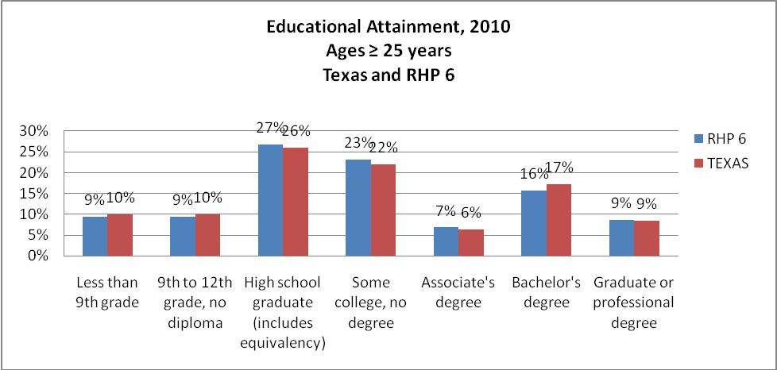

Economics
In 2010, the per capita income in RHP 6 was $35,989, compared to $38,609 statewide. Individual counties vary widely as evidenced by Zavala County’s per capita income of $17,892 and Gillespie County with $44,723.
In 2010, the unemployment rate for RHP 6 was 7.4%, better than the state’s rate of 8.2%. As expected, the unemployment rate is correlated with education and per capita income and varies widely by county. Zavala County had an unemployment rate of 15.6%, while Gillespie County had the lowest rate of 4.8%.
In 2009, Some 380,000 residents, approximately 16% of the population, lived below the poverty line in RHP 6. Forty percent of those living below poverty are children under the age of 18 years. Poverty rates vary significantly by county with Kendall County at 8.6% and Zavala County at 35.6%.
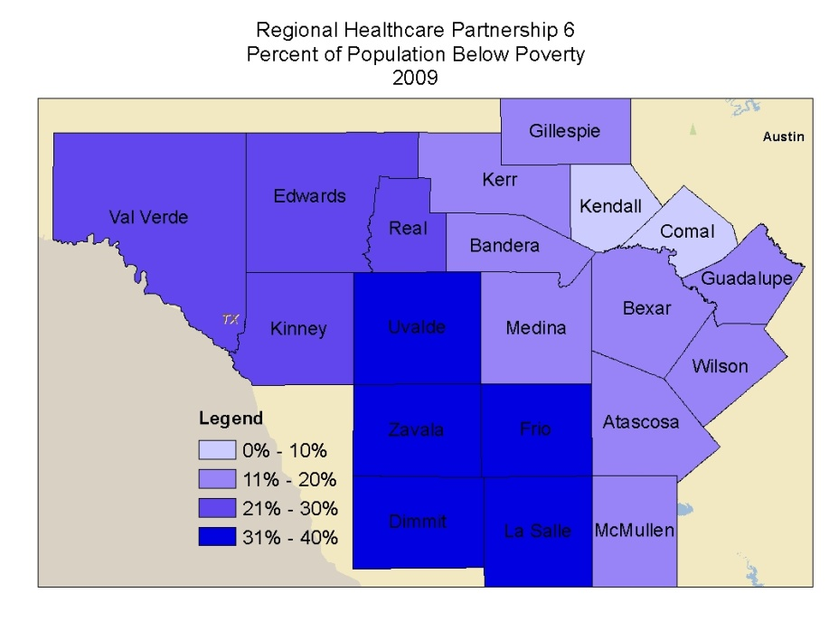
RHP 6 is home to many companies and organizations that employ a significant number of residents from each of the 20 counties. Some of the major employers are listed in Table 1.

Table 1. Largest Employers In RHP 6 By County
County | Largest Employers
Atascosa | HEB, Jourdanton Independent School District, Long and Associates, Lytle Independent School District, Pleasanton Independent School District, Poteet Independent School District, SBH Corporation, San Miguel Electric, Tristar, Wal-Mart
Bandera | Bandera Electric Coop, Bandera Independent School District, Bandera Rehabilitation Center, Bandera County, Flach Masonry, Flying L Guest Ranch, Mayan Dude Ranch, Medina Children’s Home, Medina Independent School District, Super S Foods
Bexar | USAA, Valero, University Health System, City of San Antonio, City Public Service, Department of Defense, San Antonio Independent School District, Methodist Healthcare, Baptist Health System, University of Texas at San Antonio, University of Texas Health Science Center at San Antonio
Comal | Checks In the Mail, Comal Independent School District, Eden Home, Gristmill Restaurant, HEB Grocery, Lightning Metal Specialties, McKenna Health Management, Mission Valley Fabrics, New Braunfels Independent School District, New Braunfels Smoker
Dimmit | Carrizo Springs Independent School District, Community Services Health Start, Dimmit Memorial Hospital, Middle Rio Grande Workforce, US Border Patrol, Wal-Mart
Edwards | Champion Laboratories, Kasha Industries, Pallet Solution, Wabash Valley Service Company, Huff Sealing
Frio | Pearsall Independent School District, Frio County, Dilly Independent School District, City of Pearsall, Chesapeake Energy
Gillespie | Hill Country Memorial Hospital, Fredericksburg Independent School District, Knopp Nursing/Retirement Home, HEB, Wal-Mart
Guadalupe | Texas Power Systems, Seguin Independent School System, Continental, CMC, Tyson
Kendall | Boerne Independent School District, Wal-Mart, Mission Pharmacal, HEB, Kendall County
Kerr | Peterson Regional Medical Center, Kerrville Independent School District, Kerrville State Hospital, Veterans Administration, Wal-Mart, HEB, Ingram Independent School District, James Avery Craftsman
Kinney | Rio Grande Electric Cooperative, Brackett Independent School District
La Salle | Texas Department of Criminal Justice, Cotulla Independent School District, City of Cotulla, LaSalle County
Medina | Medina Valley Independent School District, Hondo Independent School District, Devine Independent School District, Medina Regional Hospital, Medina County
McMullen | McMullen County ISD, Sam’s Club, Chesapeake Energy, Petrohawk, Swift Energy
Real | Big Springs Charter School, Leakey Independent School District
Uvalde | Southwest Texas Junior College, Uvalde Consolidated Independent School District, AgriLink Foods, Williamson-Dickie Manufacturing, HEB
Val Verde | Laughlin Air Force Base, Law enforcement agencies, Val Verde School District, Val Verde Regional Medical Center, City of Del Rio
Wilson | La Vernia Independent School District, Floresville Independent School District, Connally Memorial Medical Center, Wal-Mart, Lyssy and Eckel Feeds
Zavala | Crystal City School District, Lopez Health Systems, Inc., Del Monte, Inc., Chespeake Energy, CML Exploration, Petrohawk

Insurance Coverage
In 2009, some 471,000 residents (24%) of RHP 6 lacked health insurance coverage. A major reason for the lack of coverage is the large number of residents, particularly in rural areas, that work for small businesses or who are self-employed. In Texas, only 31% of firms with fewer than 50 employees offer health insurance.
Of those with coverage, 317,000 residents were enrolled in Medicare and more than 355,000 residents were enrolled in Medicaid. 70% of Medicaid enrollees were children. Of the adults enrolled in Medicaid, 54% were blind and/or disabled.

Current Healthcare Infrastructure
In 2009, there were 33 acute care hospitals in RHP 6, including nine public and three private/non-profit hospitals. In addition, there were four psychiatric hospitals. RHP 6 has a total of 7,430 licensed acute care beds, 77% of which are staffed. Sixty-five percent of the 746 licensed psychiatric beds are staffed.
In 2010, acute care gross patient revenues in the region totaled $13.7 billion. Net patient revenue totaled $4.7 billion. Hospitals provided $1.7 billion in uncompensated care.
Table 2 below shows the number of health care providers in RHP 6 in 2009. As stated previously, the population of RHP 6 represents about 9% of the state’s population, and the percent of providers in RHP 6 is consistent with population distribution. Health professionals tend to be primarily located in Bexar County.

Table 2. Health Care Providers in RHP 6
 | Number of Providers in RHP 6 | Percent of Texas Providers in RHP 6 | Percent of RHP 6 Professionals in Bexar County
Direct Care Physicians | 4,066 | 10% | 85%
Primary Care Physicians | 1,649 | 9% | 80%
Physician Assistants | 594 | 12% | 83%
Registered Nurses | 17,789 | 10% | 85%
Licensed Vocational Nurses | 8,642 | 12% | 75%
Nurse Practitioners | 512 | 8% | 84%
Dentists | 1,167 | 10% | 81%
Pharmacists | 1,932 | 9% | 81%
EMS Personnel | 4,976 | 9% | 58%

Nearly every county in RHP 6 is designated as a Health Provider Shortage Area (HPSA) for primary care, mental health, and/or dental services. A HPSA is a geographic area, population group, or health care facility that has been designated by the Federal government as having a shortage of health professionals. HPSAs are designated using several criteria, including population-to-clinician ratios. This ratio is usually 3,500 to 1 for primary care, 5,000 to 1 for dental health care, and 30,000 to 1 for mental health care.
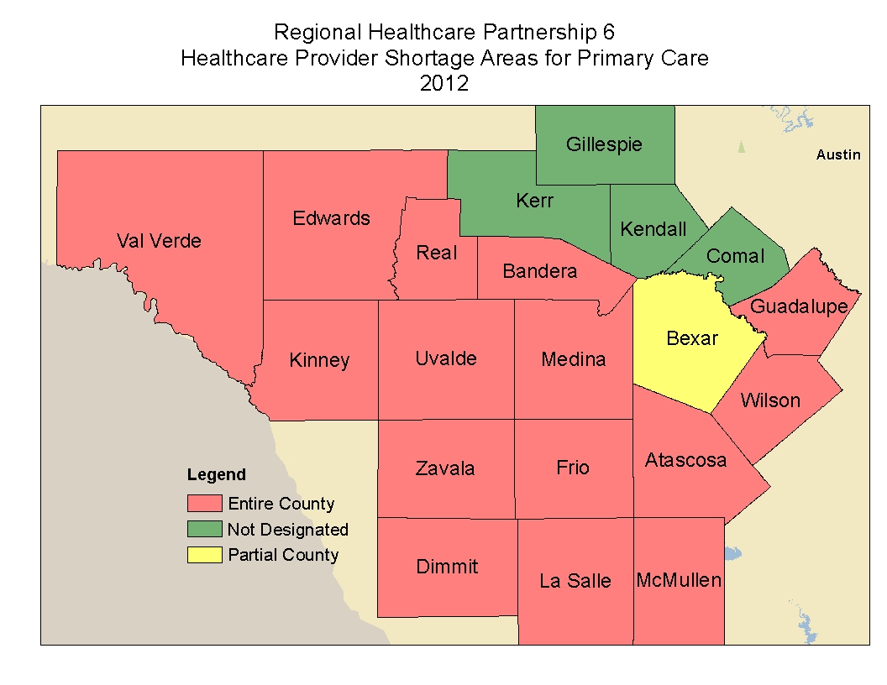
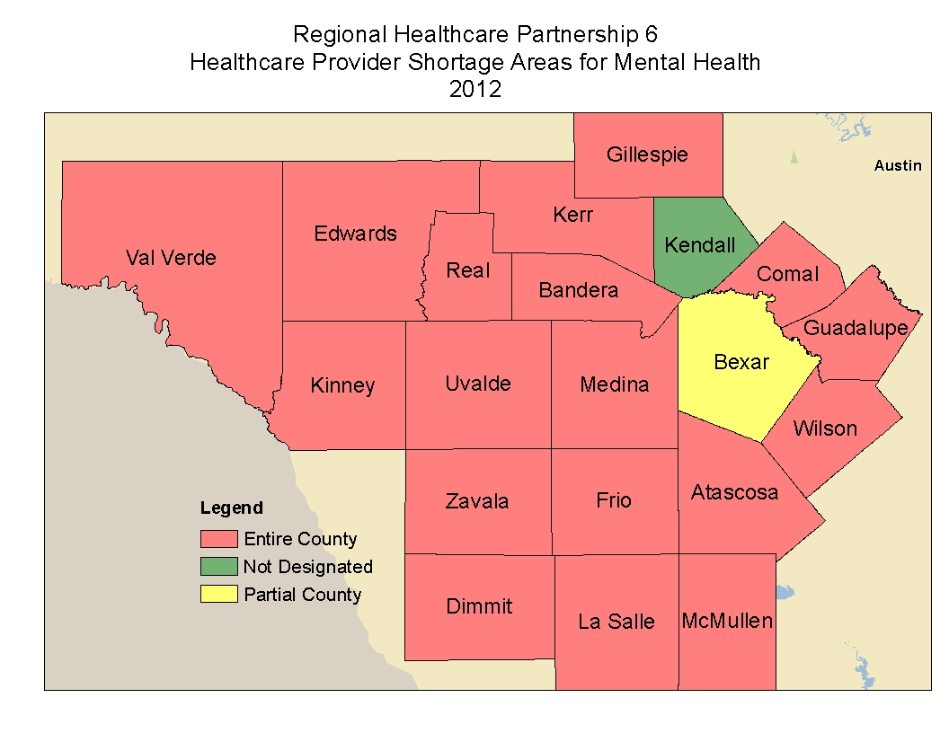
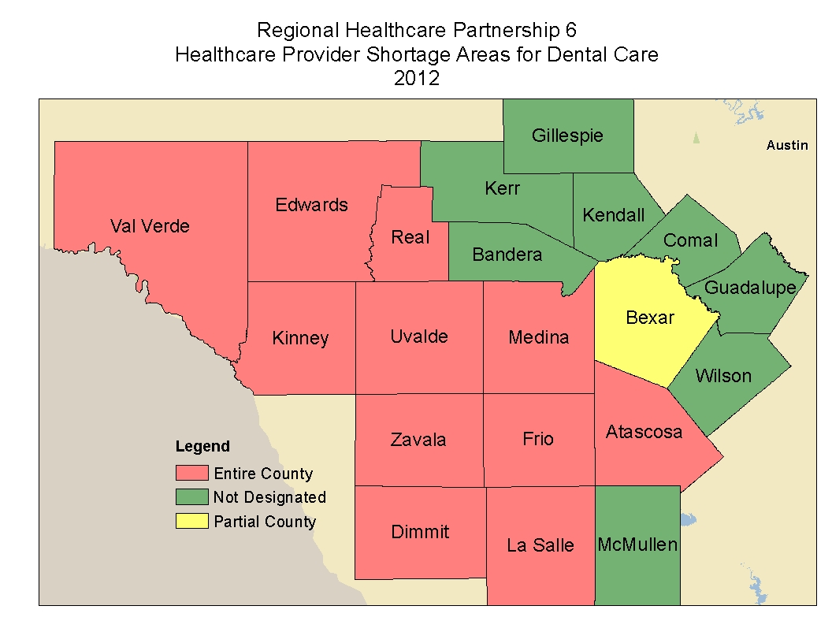

Projected Major Changes
Demographics
The total population in RHP6 is expected to grow 6% between 2010 and 2015. The population change projections for 2015 vary widely by individual counties within RHP 6. The Hispanic population will experience the largest net growth of 106,000 residents. The Anglo population is expected to decrease by two percent.
According to the Center on Budget and Policy Priorities, there are four contributing factors to Texas’ projected population growth, which also apply to most of the counties in RHP 6. These include:
- “Natural growth” (i.e. births minus deaths). Texas has the nation’s second highest birth rate which has been attributed to a variety of demographic, socio-economic, and cultural factors. Natural growth accounted for 55% of Texas’ population increase between 2010 and 2011.
- Continued international migration given Texas’ proximity to Mexico. International migration accounted for 18% of Texas’ population growth between 2010 and 2011.
- Low cost of living due to supply of land and low housing prices.
- Oil and gas industry. The recently developed Eagle Ford Shale significantly impacts RHP 6 “producing counties” including Atascosa, Dimmit, Frio, La Salle, McMullen, Wilson, and Zavala, as well as two “peripheral counties” (Bexar, and Uvalde) involved in non-production activity. The shale activity is projected to create nearly 117,000 full-time jobs by 2021.

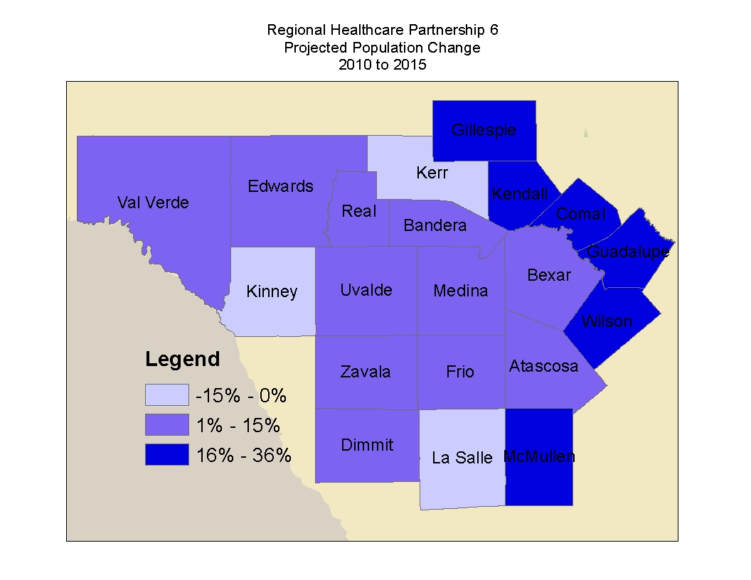

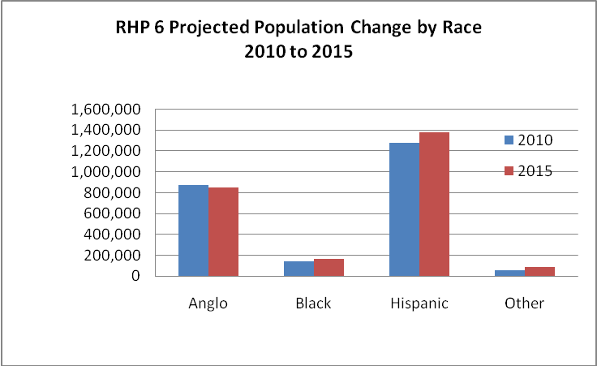

Insurance Coverage
The Patient Protection and Affordable Care Act and the Health Care and Education Reconciliation Act collectively known as the Affordable Care Act (ACA), were signed into law in March 2010, and mostly upheld by the United States Supreme Court in June 2012. One intent of this law is to increase the accessibility and affordability of health coverage for currently uninsured individuals. This coverage will be available through subsidized insurance exchanges and, if Texas elects, the expansion of Medicaid up to 133% of the Federal Poverty Level. Texas’ current insured rate of 24% is projected to decrease to 15% in 2014 if Texas chooses not to expand Medicaid coverage. The rate may decrease to 12% if Medicaid is expanded. Those remaining without coverage would include individuals eligible but electing not to enroll in Medicaid or subsidized programs, individuals not eligible for subsidized coverage, and undocumented residents. RHP 6 expects this legislation to affect its uninsured population in a manner consistent with that of the entire state.

Healthcare Infrastructure and Environment
With the rise of insured individuals, the demand on healthcare infrastructure will also increase. One of the key aims of Texas’ 1115 waiver is to “improve and prepare the health care infrastructure to serve a newly insured population.” This will require improved access to primary and mental health care, effective management of chronic disease, enhanced technology, and innovative payment mechanisms to promote high quality care and reduce the costs associated with that care.

Key Health Challenges

Health Care Quality
According to the Agency for Healthcare Research and Quality’s 2011 report, Texas ranks last in the nation on health care quality. The report is based on 155 quality measures which include disease prevention efforts, deaths from various conditions, cancer treatment, and how well health care providers manage chronic conditions such as diabetes. Under the category of “Types of Care,” Texas scored “weak” on preventive measures, acute care measures, and chronic care measures. Under the category of “Care by Clinical Area,” Texas scored “weak” on diabetes, heart disease, and respiratory measures, and “average” on cancer measures.
>>May add more specific info measures depending on DSRIP project selections
The University of Wisconsin Population Health Institute, funded by the Robert Woods Johnson Foundation, publishes an annual County Health Rankings Report. The health outcomes rankings are based on equal weighting of mortality and morbidity measures. The health factors rankings shown in Table 3 are based on weighted scores of four types of factors: behavioral, clinical, social and economic, and environmental. Higher numbers indicate better performance. Of the 221 Texas counties reviewed, Comal Gillespie, and Wilson performed well, however Atascosa, Dimmit, Edwards, Frio, Kerr, LaSalle, Real, Uvalde, Val Verde, and Wilson ranked in the lower half of all Texas counties. Kinney and McMullen counties were not ranked in the report.

Table 3. County Health Rankings
County | Health Factors Ranking | Health Outcomes Ranking
Atascosa | 178 | 134
Bandera | 47 | 95
Bexar | 84 | 73
Comal | 6 | 7
Dimmit | 217 | 52
Edwards | 194 | 105
Frio | 198 | 64
Gillespie | 3 | 5
Guadalupe | 44 | 23
Kendall | 1 | 6
Kerr | 59 | 161
La Salle | 196 | 80
Medina | 76 | 54
Real | 158 | 166
Uvalde | 195 | 67
Val Verde | 122 | 31
Wilson | 29 | 59
Zavala | 219 | 127

Health Care Provider Shortage and Access to Primary Care
Given the high number of counties in RHP 6 designated as Health Provider Shortage Areas, this region, like the rest of the state, is in need of additional providers. Recent reports show Texas ranking 45th in the nation in the number of physicians per capita. The state's growing population, increased longevity of its residents, vast expanses of rural and border areas, growing prevalence of chronic diseases, greater availability of specialty services and breakthroughs in medical science are all contributing to an accelerating demand for physicians.
The shortage of providers is one reason many hospitals report high emergency room utilization. Not only is this an expensive way to deliver health care, but it also means that the individuals accessing this care tend to receive less preventive care, less comprehensive care, and they often delay seeking treatment until the illness is severe and advanced. Greater access to high quality primary care has been shown to result in improved health outcomes.

Mental and Behavioral Health
In Texas, community mental health centers, also referred to as Local Mental Health Authorities (LMHAs) provide services to a specific geographic area of the state, called the local service area. Four community centers serve RHP 6 as shown in Table 4.

Table 4. RHP 6 Local Mental Health Authorities
Community Center | Counties Served
Bluebonnet Trails | Guadalupe
Camino Real Community Services | Atascosa, Dimmit, Frio, LaSalle, McMullen, Wilson, Zavala
Center for Health Care Services | Bexar
Hill Country Mental Health and Developmental Disabilities Centers | Bandera, Comal, Edwards, Gillespie, Kendall, Kerr, Kinney, Medina, Real, Uvalde, Val Verde
In addition to providing services, LMHA's have specific responsibilities. The Texas Department of State Health Services requires each authority to plan, develop policy, coordinate and allocate and develop resources for mental health services in the local service area.
A March 2011 report published by the Hogg Foundation for Mental Health and Methodist Healthcare Ministries warns the most severe health profession shortages are in mental health services, with Texas ranking far below the national average in number of mental health professional per 100,000 residents. Further, less than 33% of the state’s 48,700 practicing doctors accept Medicaid patients and nearly every county in RHP 6 is designated as a Health Provider Shortage Area for mental health. Inadequate mental health services results in avoidable costs to hospital and criminal and juvenile justice systems. Strategic Planning sessions sponsored by the Bexar County Commissioners Court and Methodist Healthcare Ministries have identified the following issues:
- Inadequate and fragmented continuum of care for children with behavioral health diagnoses
- Need for integrated behavioral health and primary care services
- Inadequate access to care management and resource navigation
- Inadequate services for individuals who have been arrested or incarcerated either as a result or precipitated by unmet behavioral health needs
- Inadequate resources for special needs populations (e.g., homeless adults, sex offenders) including efficiencies such as integrated behavioral and primary care, pharmacy services, telemedicine, and physician extenders
- Inadequate outpatient care for adults with moderate acuity behavioral health needs to support reductions in hospital readmissions and the inappropriate use of emergency departments

Chronic Disease
Cardiovascular disease, cancer, unintentional injuries, and diabetes top the list of causes of death in RHP 6. Of the 16,000 deaths in 2008, 60% were due to these causes that are potentially preventable. Disease management and wellness programs are critical to reducing morbidity and mortality of these diseases.
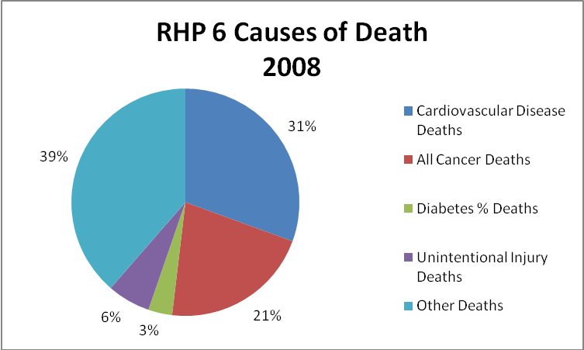

Maternal Health
Of the 36,000 live births in RHP 6 in 2008, only 59% of mothers received prenatal care within the first trimester. Six percent of births occurred to girls under 18 years of age and 44% of births were to unmarried mothers. Bexar County, which has the highest number of births, reports an adolescent (ages 13-17 years) pregnancy rate of 30.6 per 1,000 women, compared to 26.1 for the state. This rate is even higher in nine other RHP 6 counties. Nine percent of babies were born with low birth-weight. Prematurity and low birth weight can contribute to long term health and economic costs to the family and society.

2012 Bexar County Community Health Improvement Plan
The City of San Antonio Metropolitan Health District and the Bexar County Community Health Collaborative presented a Community Health Improvement Plan for Bexar County in May 2012. This plan, shown in Table 5, was compiled with input from multiple stakeholders and based on the 2010 Bexar County Community Health Assessment. It sets priorities for health improvement and engages partners and organizations to develop, support, and implement the plan.

Table 5. Community Health Improvement Plan for Bexar County
Priority Area | Health Issues | Goal
Healthy Eating and Active Living | - 68% of the Bexar County population is overweight  - 77% of respondents reported engaging in some type of activity for exercise.  - The diabetes rate in Bexar County is 10% and more than double among African Americans (14%) and Hispanics (13%), compared to Whites (6%). | Foster social change and strengthen positive behaviors around healthy eating and active living to ensure access to nutritious foods and build environments that enable all residents to make healthy choices and lead healthy lives.
Healthy Child and Family Development | - More than 25% of pregnant women in Bexar County received late or no prenatal care.  - 9.4% of Bexar County babies are born with low birth weight.  - 57% of Bexar County Head Start participants reported to have dental caries | Make pregnancy and early childhood the focus of system level changes that support healthy child and family development.
Safe Communities | - Unintentional injuries were responsible for 74 hospitalizations per 10,000 people in 2008, in Bexar County  - Unintentional injuries were responsible for almost 478 years of potential life lost from age 65 in Bexar County in 2008.  - Motor vehicle accidents were one of the leading causes of death in Bexar County in 2008 for adults and children. | Develop safe neighborhoods by identifying what woks locally, planning how to replicate successes in our neighborhoods, and enhancing systems that respond effectively to community-identified safety needs.
Behavioral Health and Mental Well-Being | - About 6 people per 1,000 are hospitalized for mental disorders every year in Bexar County  - About 1 person in 10,000 dies every year in Bexar County due to suicide, adjusted for age. In 2008, this rate added up to 245 years of potential life lost per 100,000 under age 65 due to suicide for the residents of Bexar County  - 28% of youth in Texas reported feeling sad or hopeless every day for two weeks  - Nearly 10 times as many Hispanic youth utilized state mental health services compared to the number of White and African American youth who utilized the same services. | Improve comprehensive behavioral health services and access for all.
Sexual Health | - 14% of Bexar County births in 2008 were to mothers under the age of 20.  - 46% of births in Bexar County in 2008 were to single mothers.  - For Chlamydia, Gonorrhea, Syphillis, and HIV, the number of cases increased between 2003 and 2008. This increase was most pronounced for Chlamydia where the number of cases increased from 6,742 in 2003 to 8,849 in 2008. | Ensure that males and females have access to education and resources to promote sexual health.

Rural Healthcare
Half of the counties in RHP 6 (Dimmit, Edwards, Frio, Gillespie, Kinney, LaSalle, McMullen, Real, Uvalde, and Val Verde) are designated by the Health Resources and Services Administration’s Office of Rural Health Policy as rural counties. According to a Kronkosky Charitable Foundation Research Brief on Rural Healthcare, rural populations face a variety of economic, cultural, social, educational, and political disparities, which reduce the ability to live a healthy life, and the need for all types of health care services continues to grow. Federally Qualified Health Centers, Rural Health Clinics, and Critical Access Hospitals are government supported facilities that serve as safety net health care providers for rural populations. Table 6 lists the Federally Qualified Health Centers serving RHP 6.

Table 6. Federally Qualified Health Centers in RHP 6
Health Care Facility | Counties Served
Atascosa Health Center, Inc. | Atascosa, Wilson
CommuniCare Health Center | Bexar
Community Health Centers of South Texas | Guadalupe
Community Health Development, Inc. | Real, Uvalde
CentroMed | Bexar, Comal
South Texas Rural Health Services | Dimmit, LaSalle, Medina, Frio, Uvalde
United Medical Centers | Kinney, Val Verde
Vida Y Salud Health Systems, Inc. | Zavala

An additional 33 providers are designated as Rural Health Clinics by the Centers for Medicare and Medicaid. One hospital, Medina Community Hospital, is designated as a Critical Access Hospital. Eight counties in RHP 6 do not even have hospitals: Bandera, Edwards, Kendall, Kinney, LaSalle, McMullen, Real, and Zavala.
The National Rural Health Association (NRHA) has identified the following issues of particular interest to rural communities:

- Access to heath care and services, particularly a need to address health disparities and physician shortages
- Health information technology to improve physicians’ lines of communication and health care quality
- Mental health services, particularly relating to provider shortages and lack of insurance coverage
- Substance abuse
- Oral health

While 24% of the entire region is uninsured, the uninsured rate for the designated rural counties of RHP 6 is 31%, and the ten rural counties make up 61% of the region’s geographic area. This underscores the importance of safety net providers and helps explain why the issues described above of are particular relevance to RHP 6. The residents of these counties tend to be older and less educated, experience lower per capita income and more poverty than the region as a whole, further compounding the challenges faced here.

Conclusion
RHP 6 represents a vast geographic area of both rural and urban communities. Continued population growth is expected to exacerbate current health challenges, including provider shortages, high rates of chronic disease, and lack of access to primary and mental health care.

United States Census County Quick Facts. http://quickfacts.census.gov/qfd/states/48000.html, accessed July 25, 2012.
Texas Department of State Health Services. 2010 Census. http://www.dshs.state.tx.us/chs/popdat/Texas-Population,-2010/, accessed July 25, 2012.
Texas Department of State Health Services. Health Currents System. http://www.dshs.state.tx.us/hcquery/, accessed July 25, 2012.
United States Census Bureau. American Fact Finder. 2010 American Community Survey. http://factfinder2.census.gov/faces/nav/jsf/pages/index.xhtml, accessed July 25, 2012.
Texas Department of State Health Services. Health Currents System. http://www.dshs.state.tx.us/hcquery/, accessed July 25, 2012.
Texas Department of State Health Services. Health Currents System. http://www.dshs.state.tx.us/hcquery/, accessed July 25, 2012.
Texas Department of State Health Services. Health Currents System. http://www.dshs.state.tx.us/hcquery/, accessed July 25, 2012.
United States Census Bureau. 2009 Small Area Health Insurance Estimates. http://smpbff1.dsd.census.gov/TheDataWeb_HotReport/servlet/HotReportEngineServlet?reportid=21c04903c96352f77fe6fea200e1c9fd&emailname=saeb@census.gov&filename=sahie09_county.hrml, accessed July 25, 2012.
Kronkosky Charitable Foundation. Rural Healthcare Research Brief, January 2012. http://kronkosky.org/research/Research_Briefs/Rural%20Healthcare%20January%202012.pdf, accessed July 25, 2012.
Centers for Medicare and Medicaid. Medicare Enrollment Reports. July 1, 2010. http://www.cms.gov/Research-Statistics-Data-and-Systems/Statistics-Trends-and-Reports/MedicareEnrpts/Downloads/County2010.pdf, accessed July 25, 2012.
Texas Health and Human Services Commission. Medicaid Enrollment Reports. Sept 2011. http://www.hhsc.state.tx.us/research/MedicaidEnrollment/ME/201109.html, accessed July 25, 2012.
Texas Department of State Health Services. Health Currents System. http://www.dshs.state.tx.us/hcquery/, accessed July 25, 2012.
Texas Health and Human Services Commission. Charity Care and Charges for Texas Acute Care Hospitals, 2010. http://www.dshs.state.tx.us/chs/hosp/hosp5/, accessed July 25, 2012.
Texas Department of State Health Services. Health Currents System. http://www.dshs.state.tx.us/hcquery/,, accessed July 25, 2012.
United States Department of Health and Human Services. Health Resources and Services Administration. http://hpsafind.hrsa.gov/HPSASearch.aspx, accessed May 15, 2012.
Texas Department of State Health Services. 2015 Projections. http://www.dshs.state.tx.us/chs/popdat/ST2015.shtm, accessed July 25, 2012.
Center for Budget and Policy Priorities. The Texas Economic Model: Hard for Other States to Follow and Not All It Seems. http://www.cbpp.org/cms/index.cfm?fa=view&id=3739, accessed July 25, 2012.
University of Texas at San Antonio. Economic Impact of the Eagle Ford Shale, May 2012. http://utsa.edu/today/2012/05/shalestudy.html, accessed July 25, 2012.
Texas Health and Human Services. Presentation to Senate Committees on Health and Human Services and State Affairs on Joint Interim Hearing on Affordable Health Care Act. August 1, 2012. http://www.hhsc.state.tx.us/news/presentations/2012/080112-Senate-HHS-ACA-Presentation.pdf, accessed August 1, 2012.
Texas Healthcare Transformation and Quality Improvement Program
http://statesnapshots.ahrq.gov/snaps11/index.jsp?menuId=1&state=TX, accessed July 25, 2012.
County Health Rankings 2012: Texas. http://www.countyhealthrankings.org/sites/default/files/states/CHR2012_TX.pdf, accessed July 25, 2012.
Texas Medical Association. Why Texas Needs More Physicians. http://www.texmed.org/template.aspx?id=5427, accessed July 25, 2012
https://www.dshs.state.tx.us/mhsa/mh-adult-services/, accessed July 25, 2012
http://www.hogg.utexas.edu/uploads/documents/Mental_Health_Crisis_final_032111.pdf, accessed July 25, 2012.
Texas Department of State Health Services. Health Currents System. http://www.dshs.state.tx.us/hcquery/, accessed July 25, 2012.
2012 Bexar County Community Health Improvement Plan
2010 Bexar County Community Health Assessment
Office of Rural Health Policy ftp://ftp.hrsa.gov/ruralhealth/eligibility2005.pdf, accessed July 25, 2012.
Kronkosky Charitable Foundation. Rural Healthcare Research Brief, January 2012. http://kronkosky.org/research/Research_Briefs/Rural%20Healthcare%20January%202012.pdf, accessed July 25, 2012.
https://www.cms.gov/Outreach-and-Education/Medicare-Learning-Network-MLN/MLNProducts/downloads/rhclistbyprovidername.pdf, accessed July 25, 2012.
http://www.flexmonitoring.org/cahlistRA.cgi?state=Texas, accessed July 25, 2012.
Rural health issues: Implications for Rural Healthy People 2020, accessed July 25, 2012.

